PETes ultaive fistimations, the following estimates were obtained.

# Issue Rate and Running Average Approximation.

# Weibull Issue Rate Estimation

## Formula:

## Parameter Estimate:

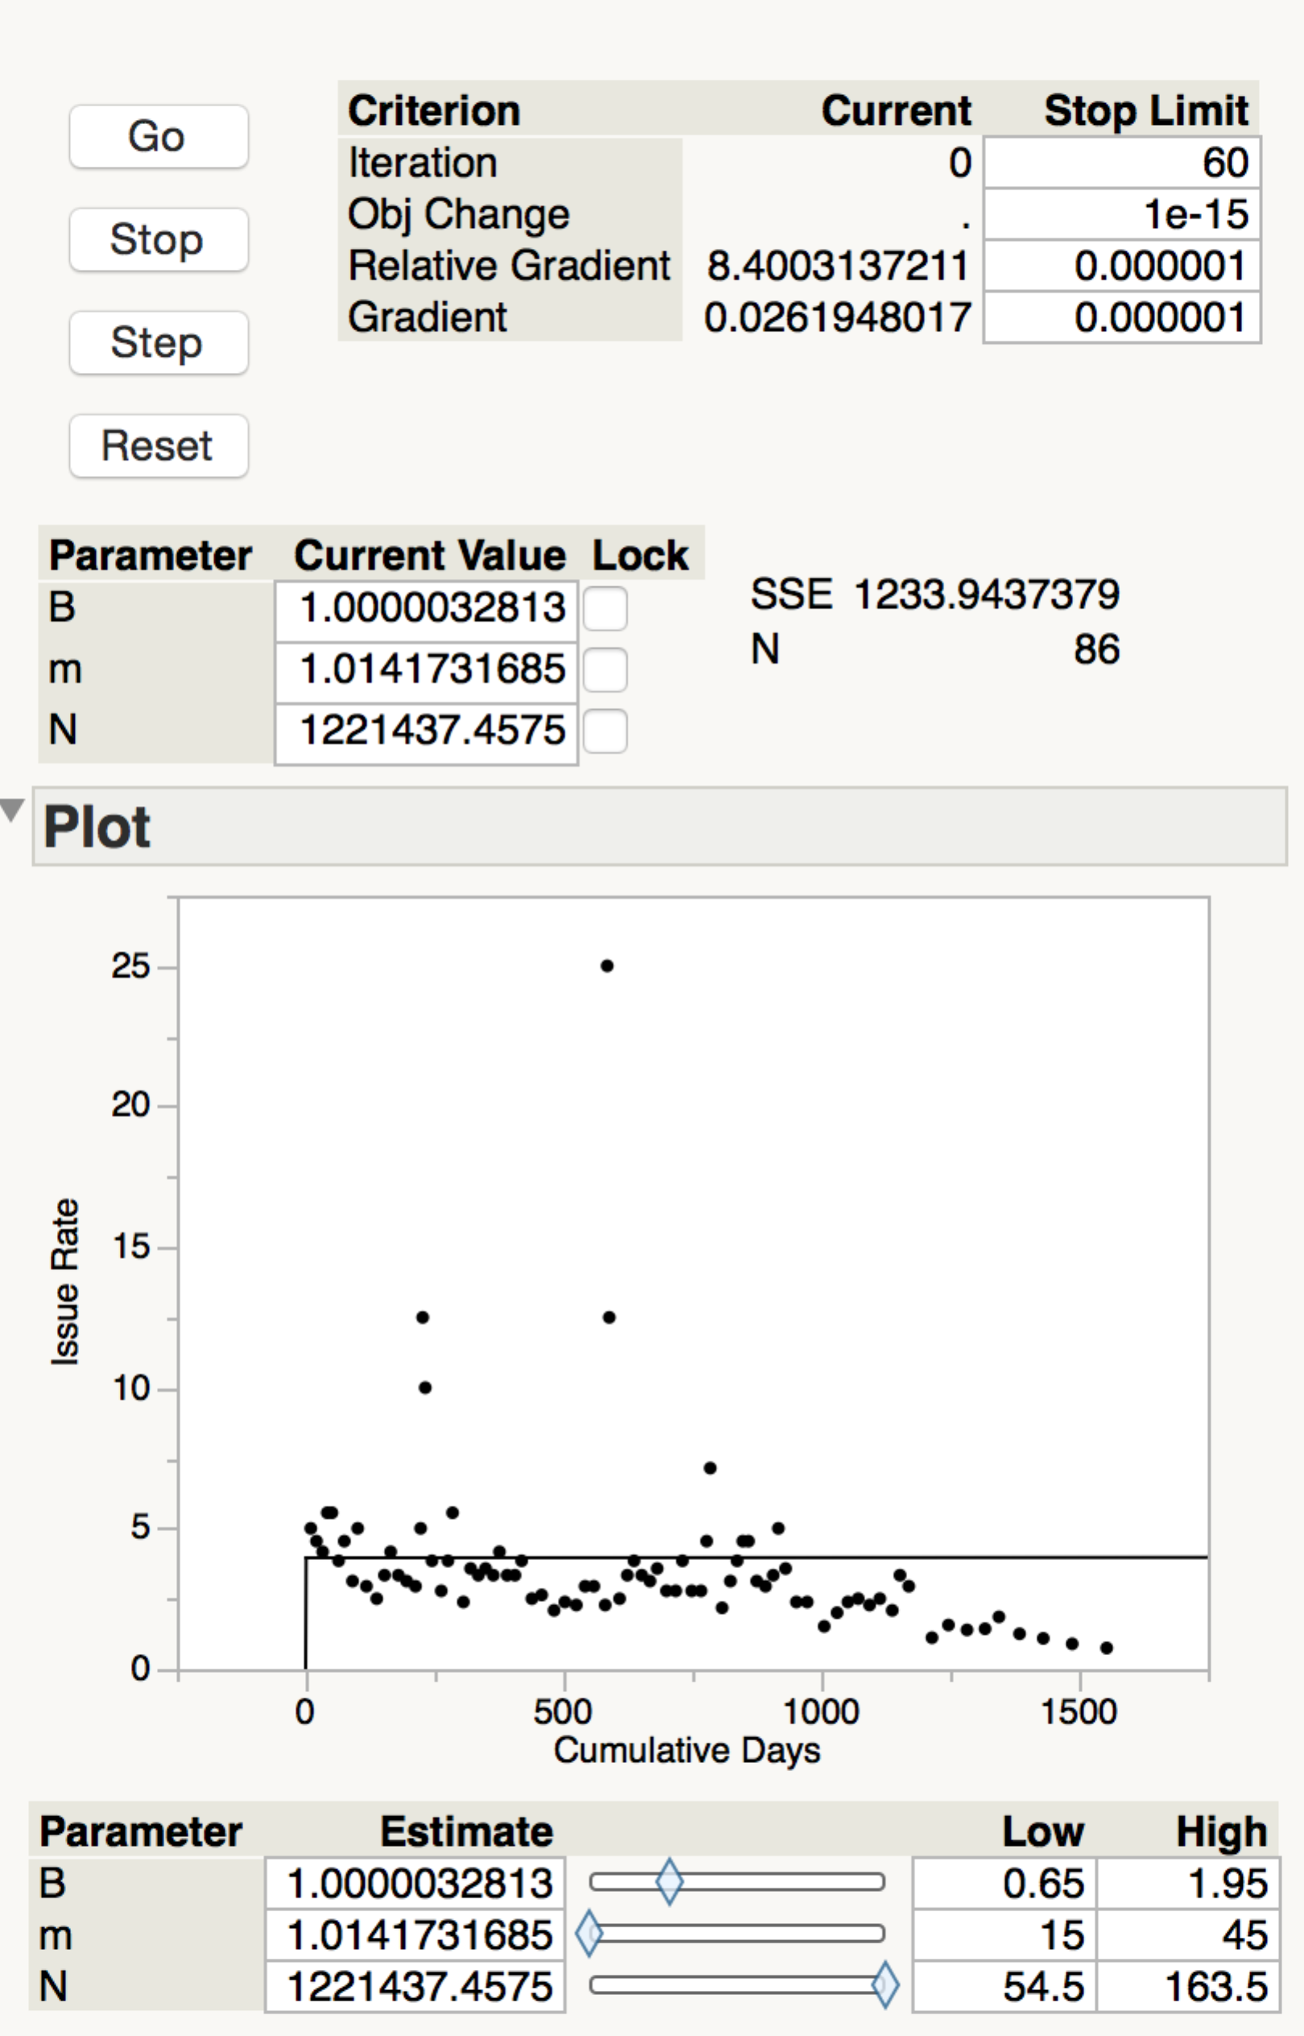

## Weibull Cum. Issue Estimate (Overlay):

Using the above estimations from the rate fit, the following estimates for cumulative issues were obtained.

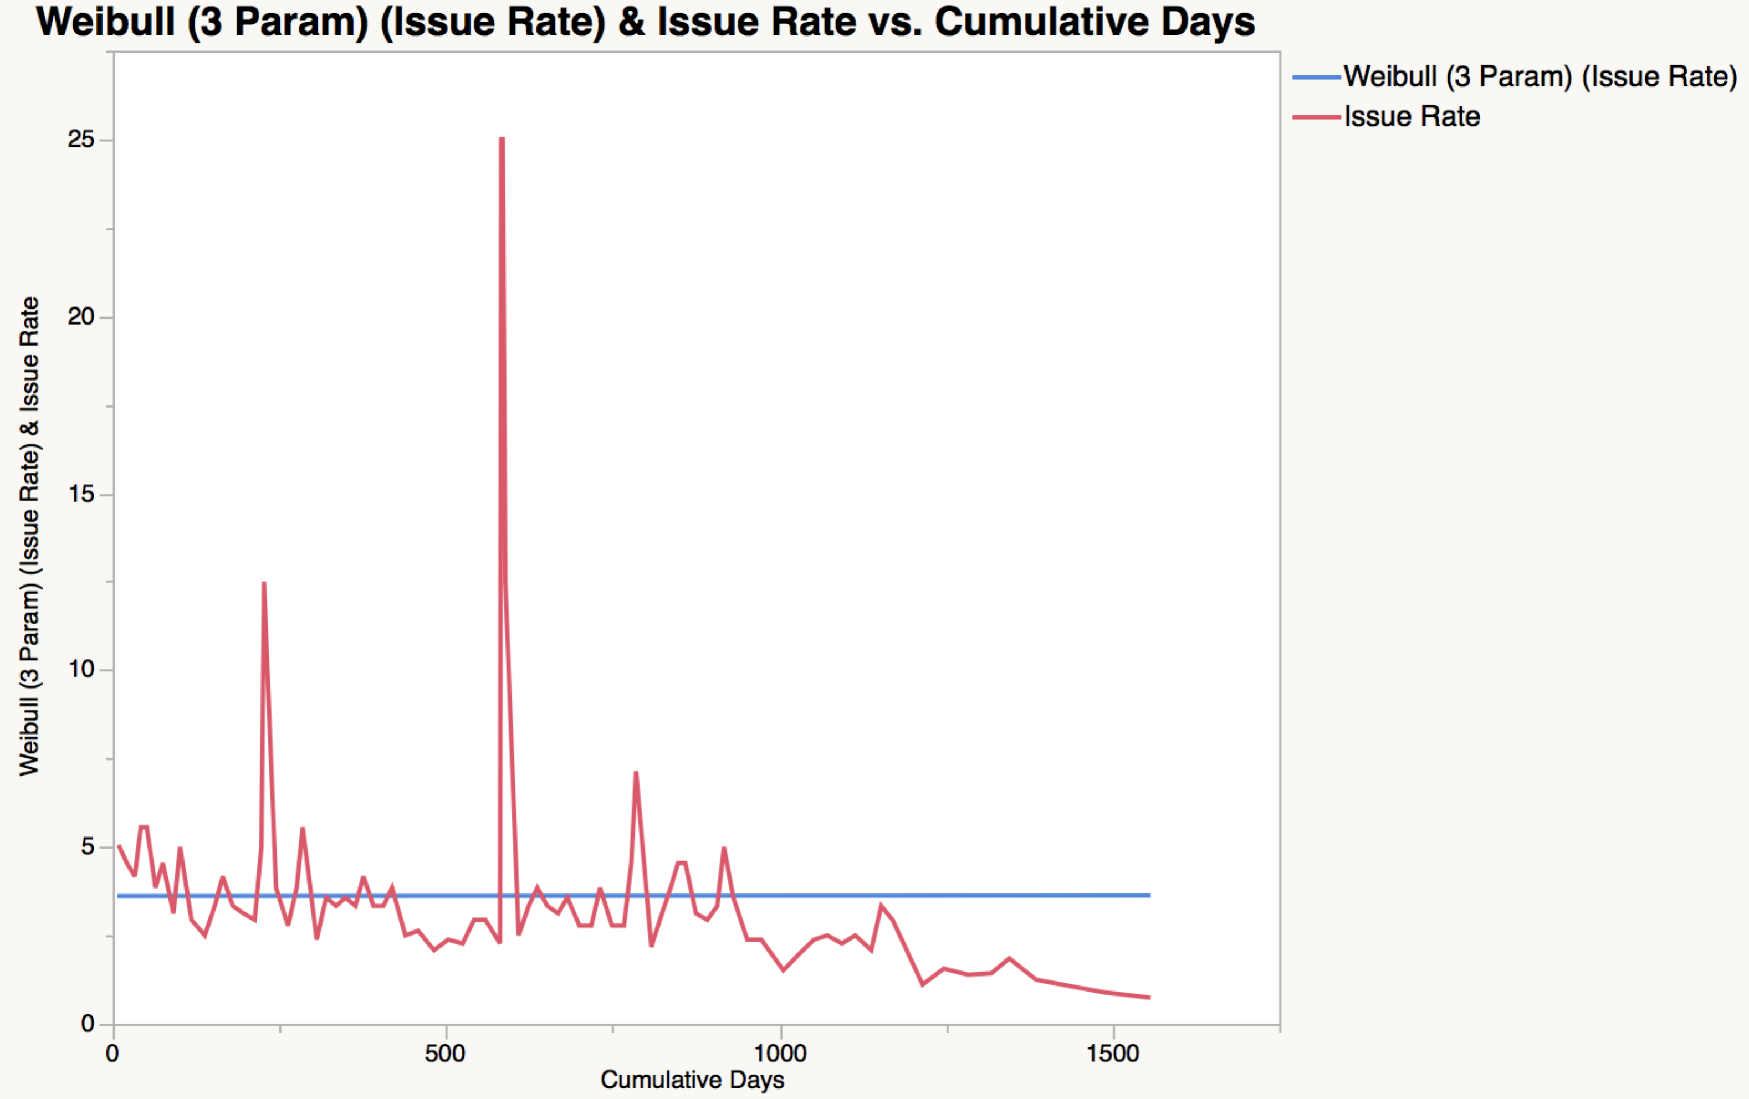

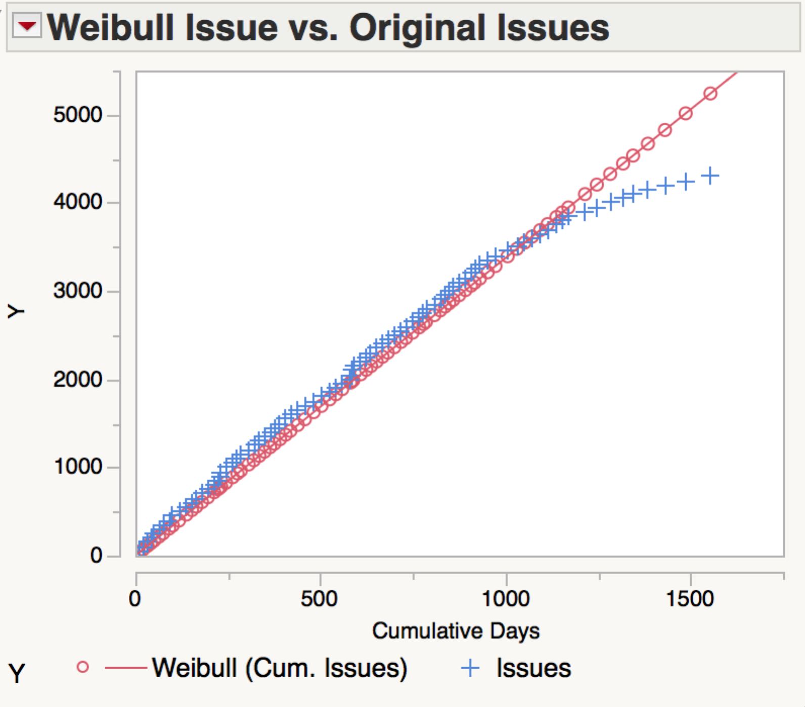

## LPET Estimator

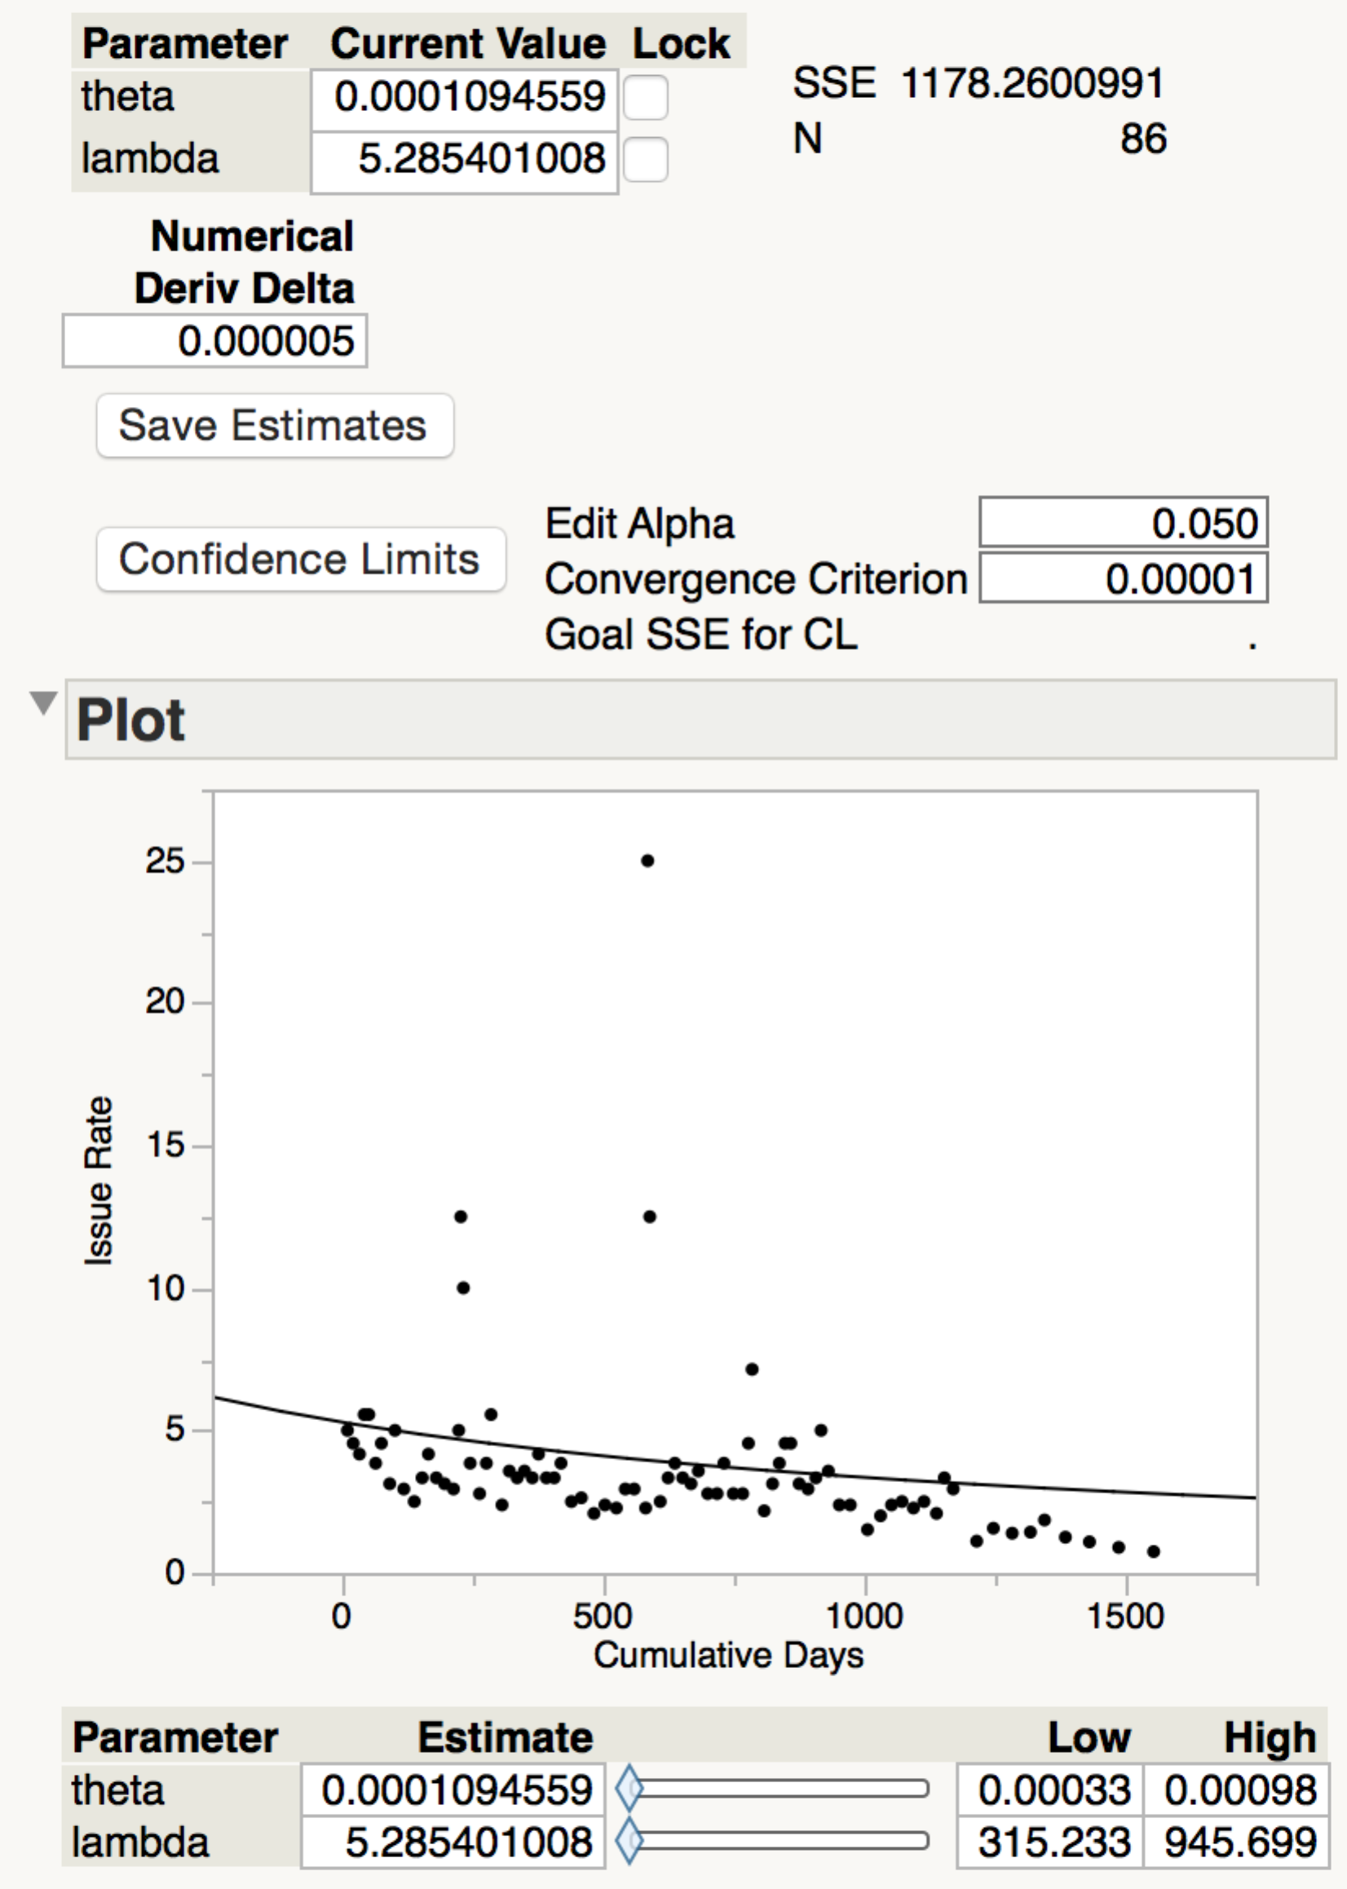

## 

## LPET Cum. Issue Estimate (Overlay):

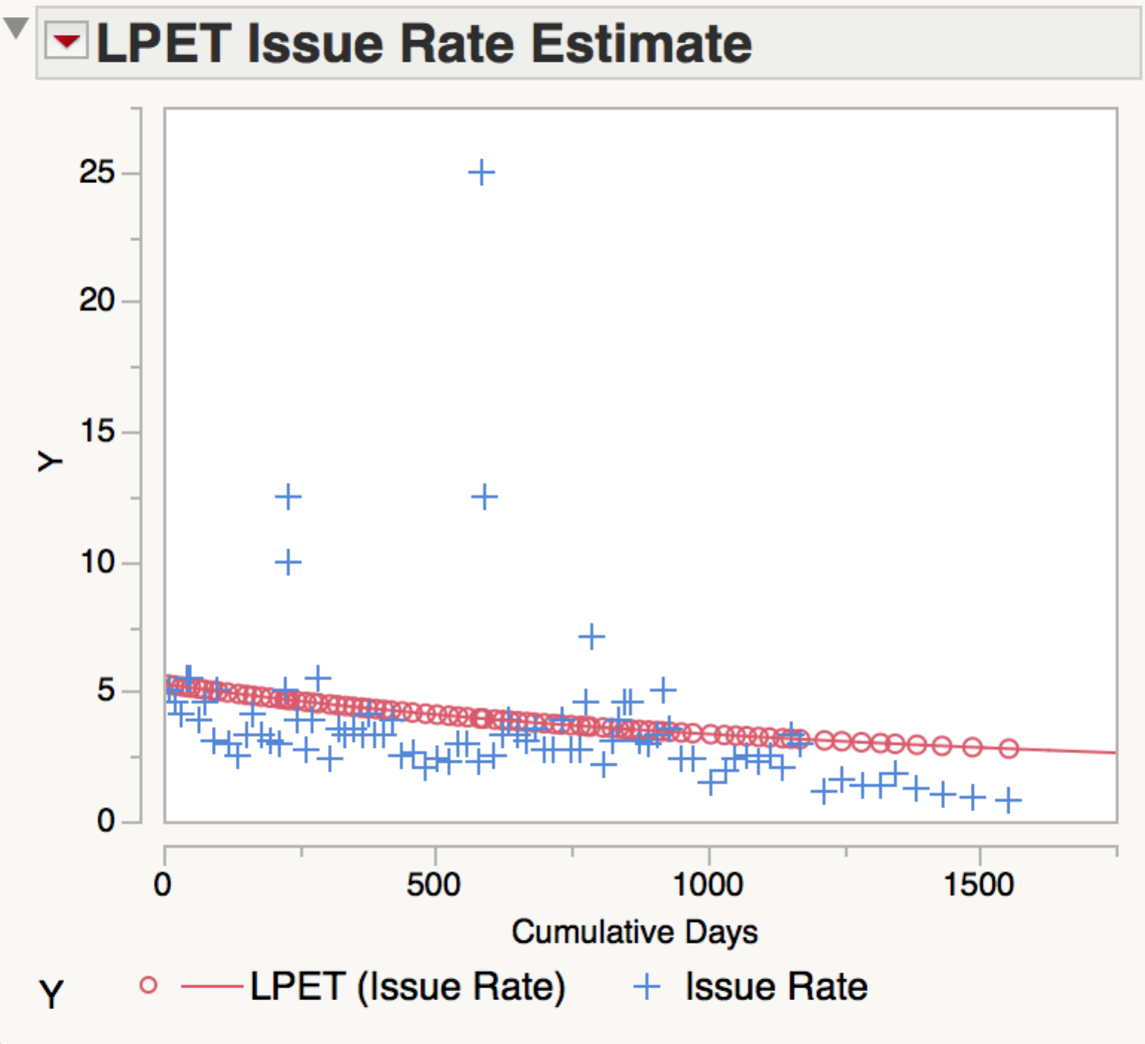

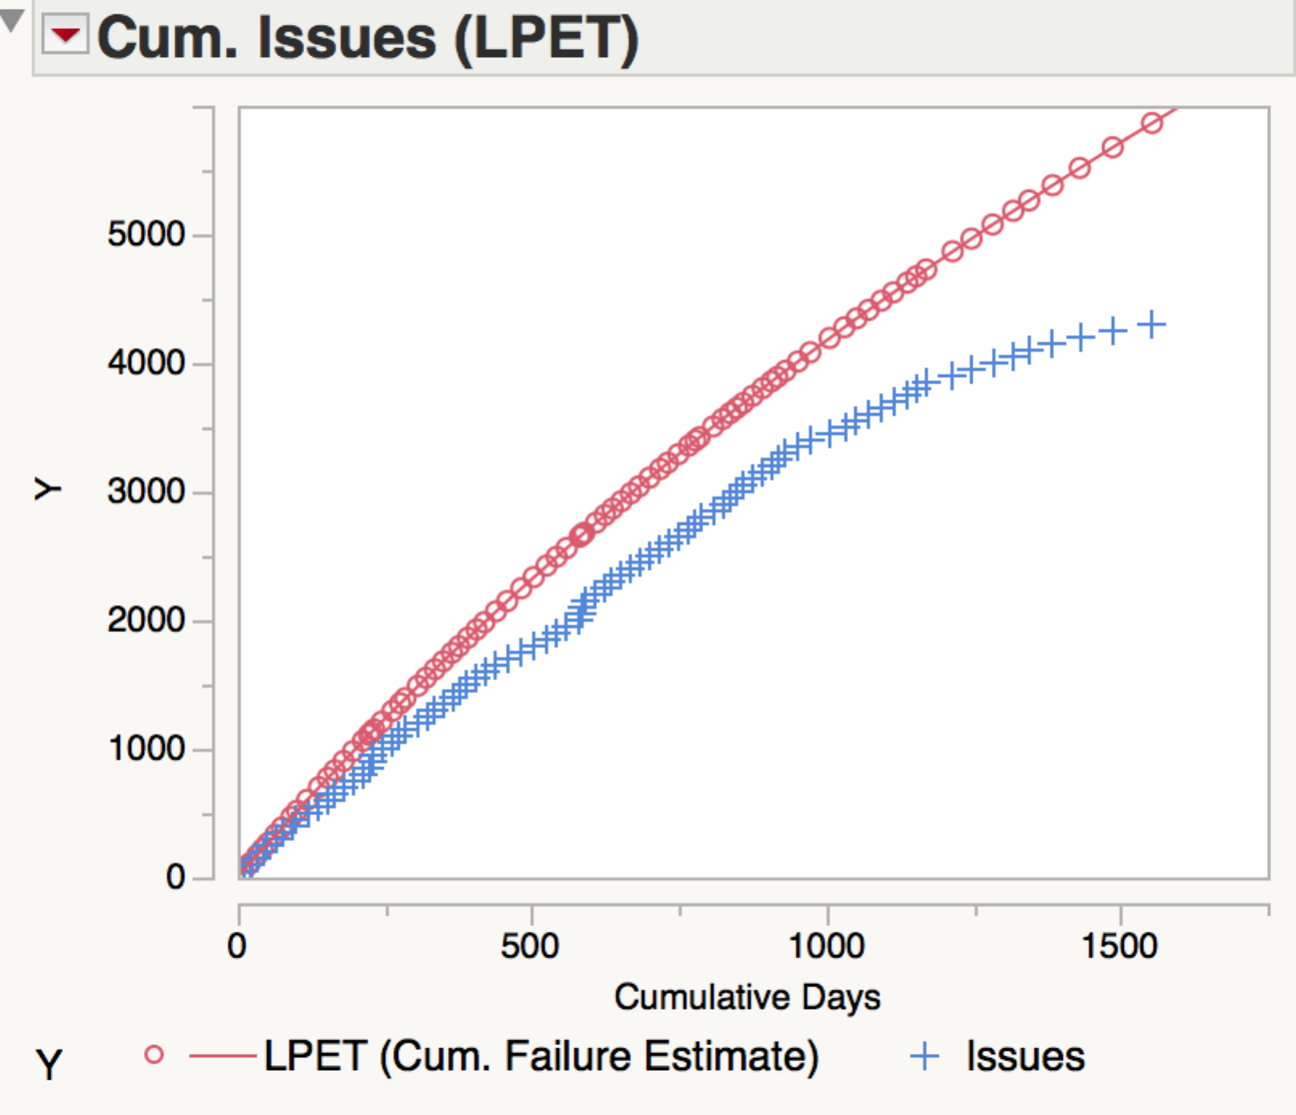

## BET Estimators

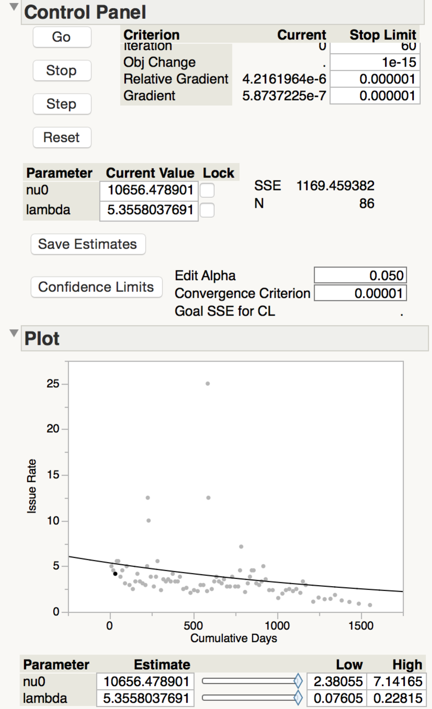

## BET Cum. Issues Estimate

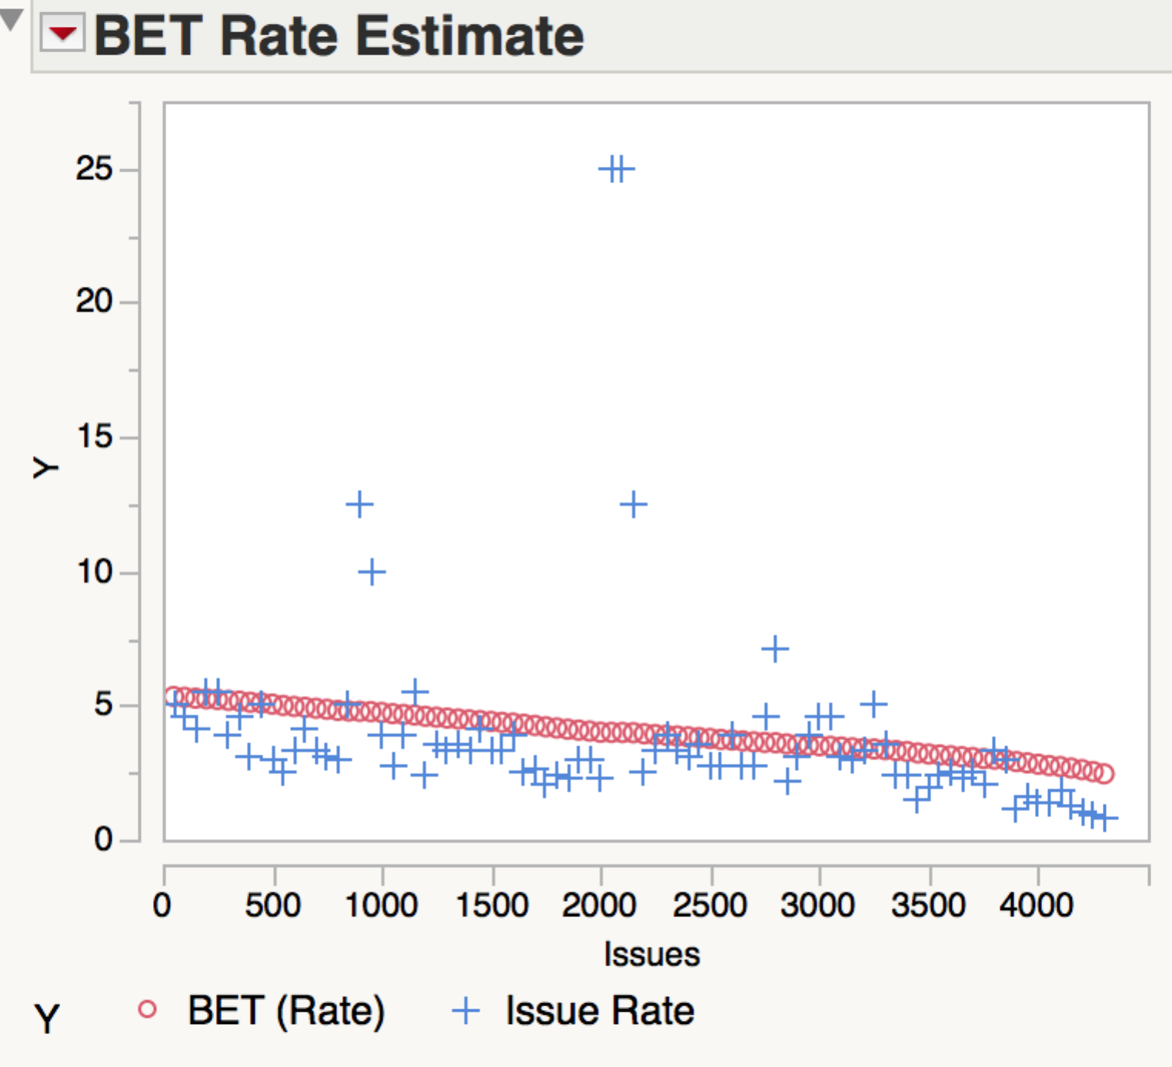

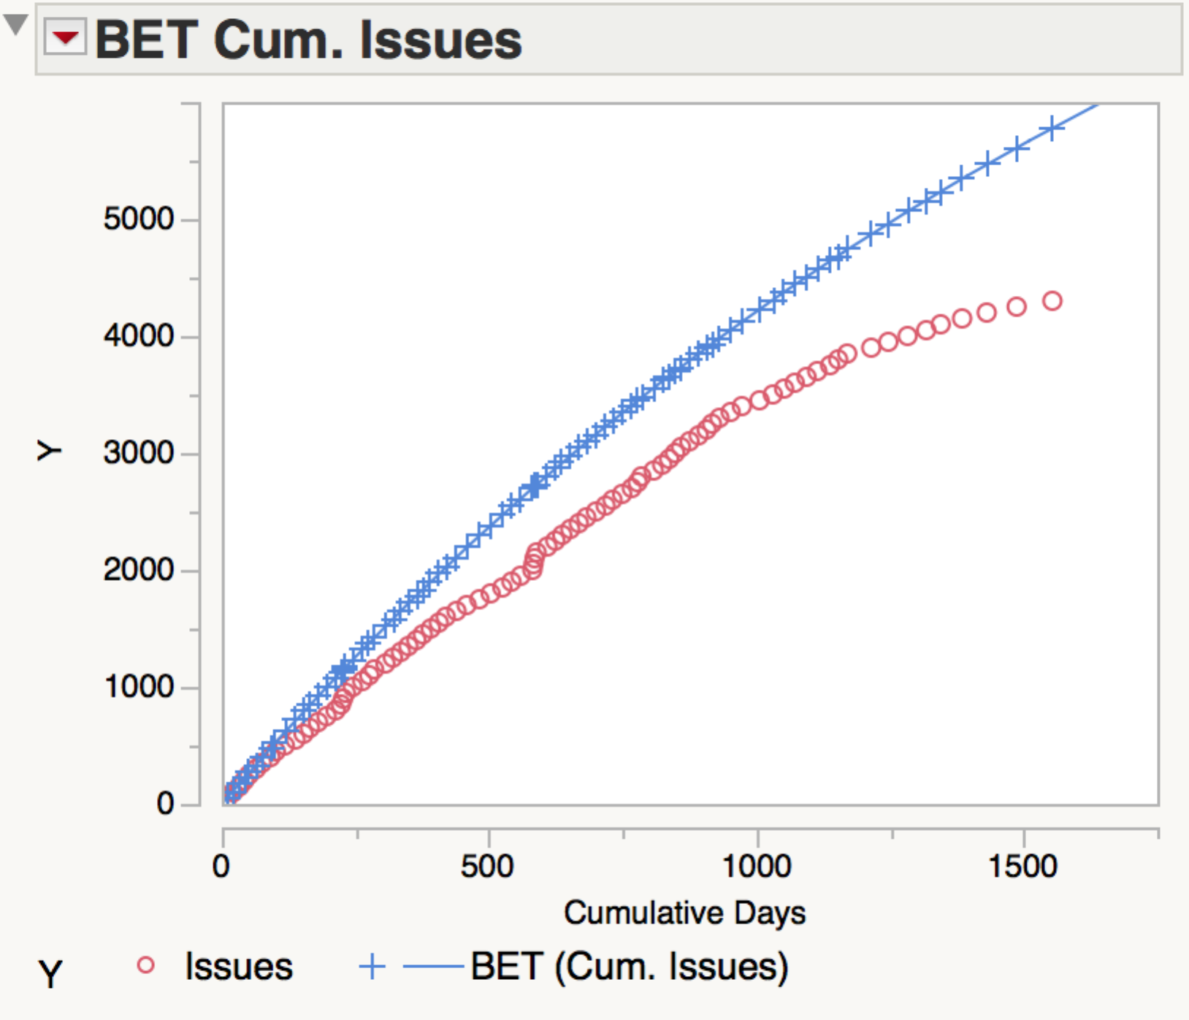

## Linear Estimator

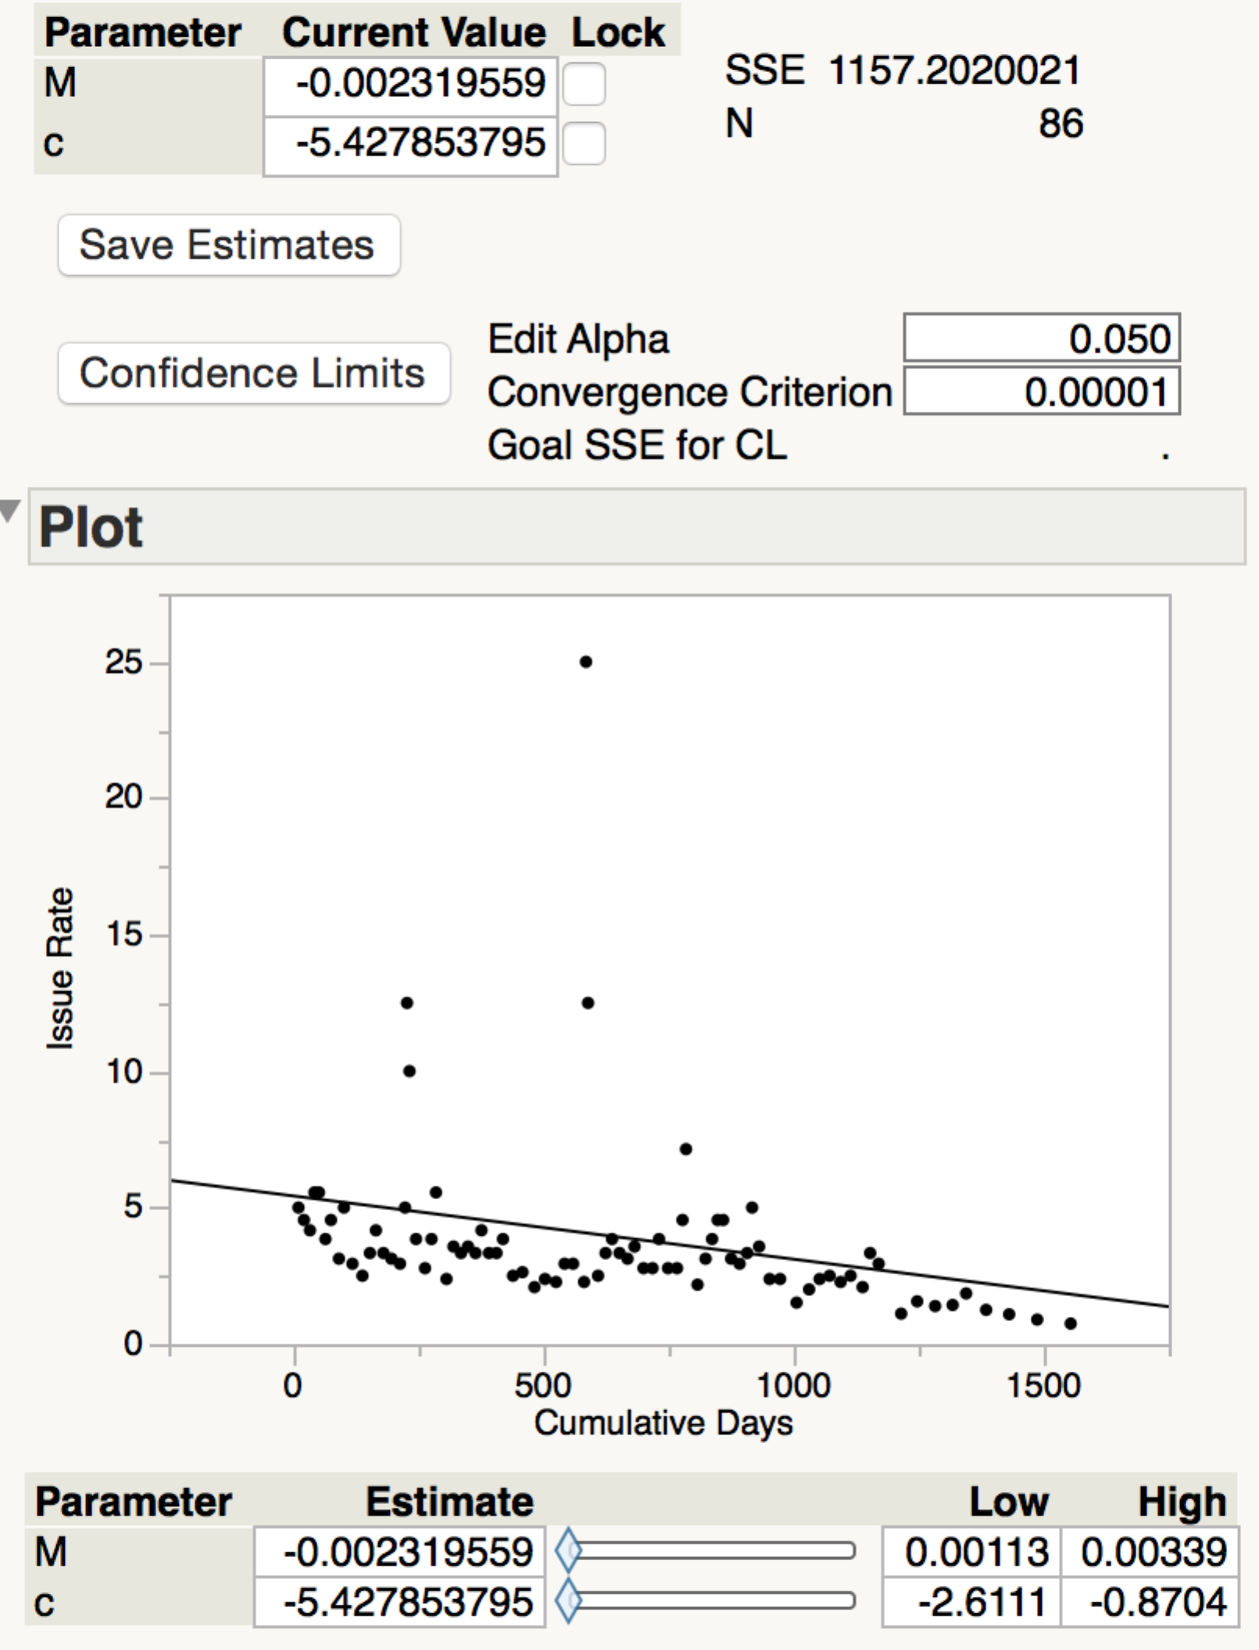

## Linear Cum. Issues Estimate

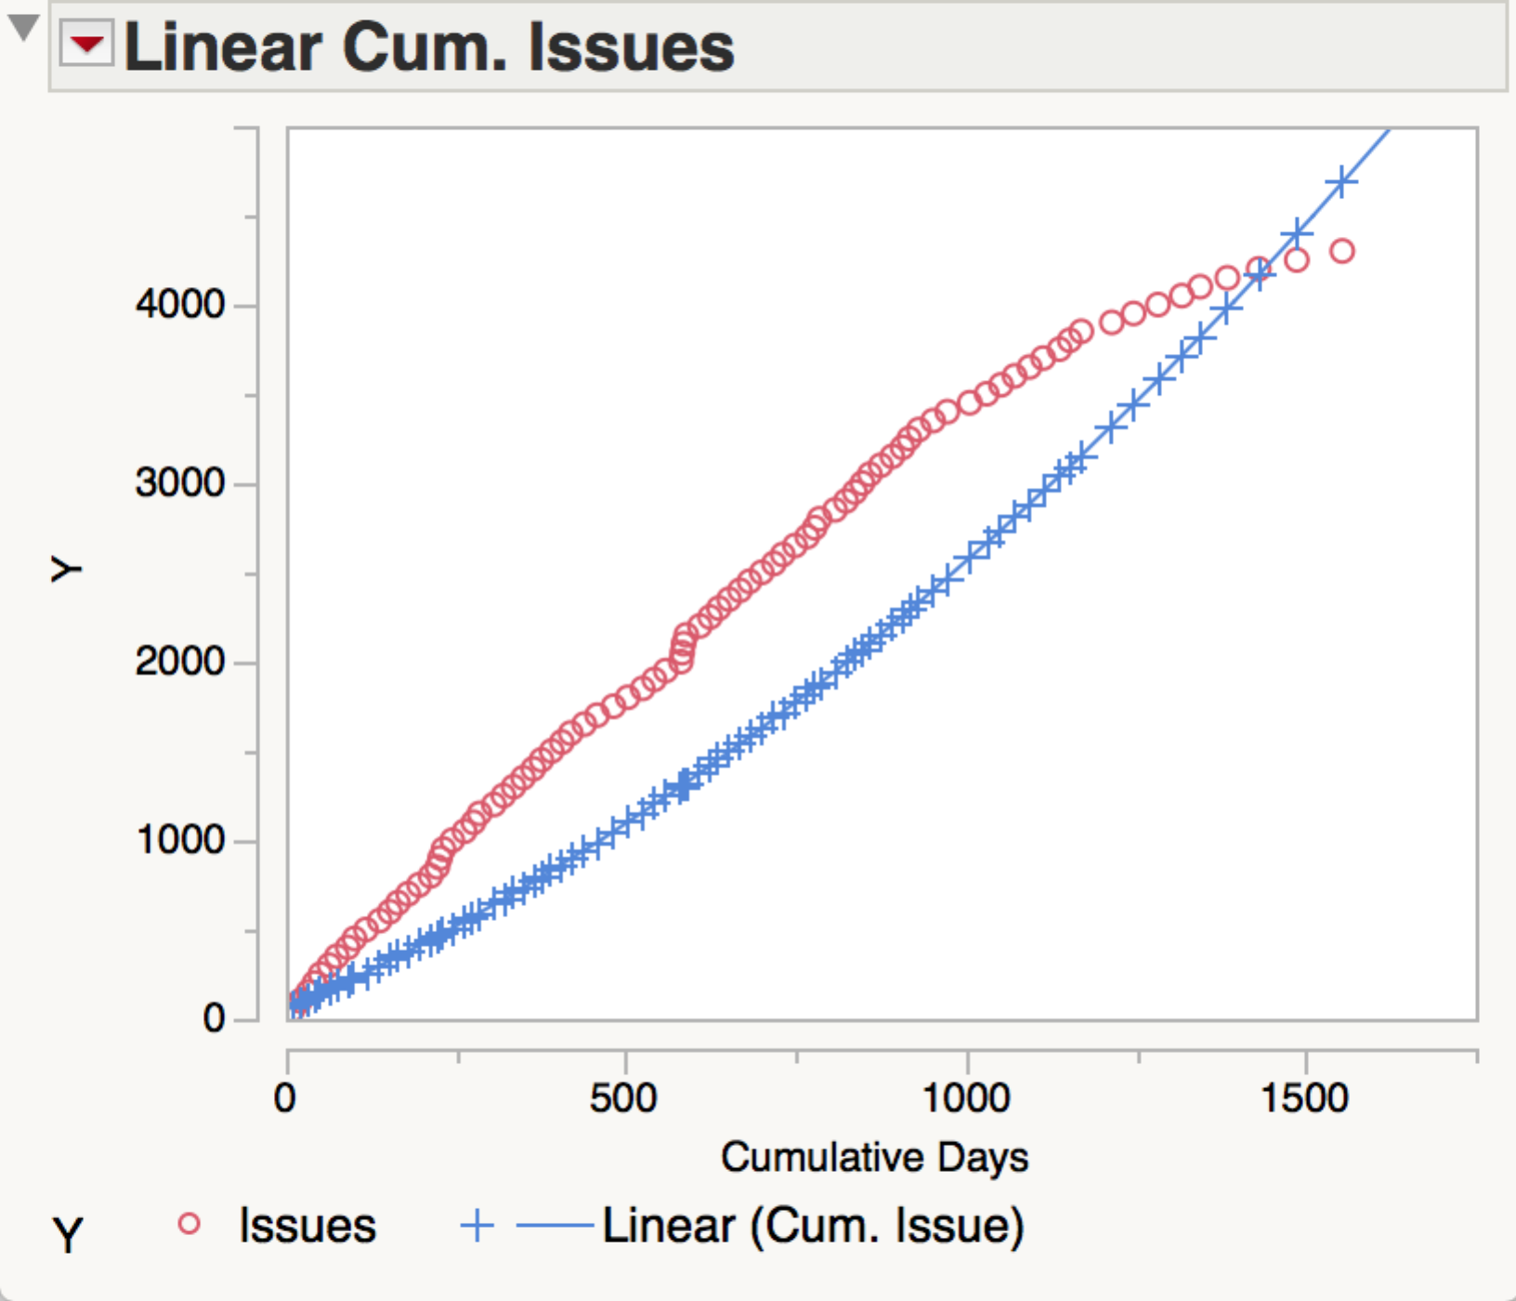

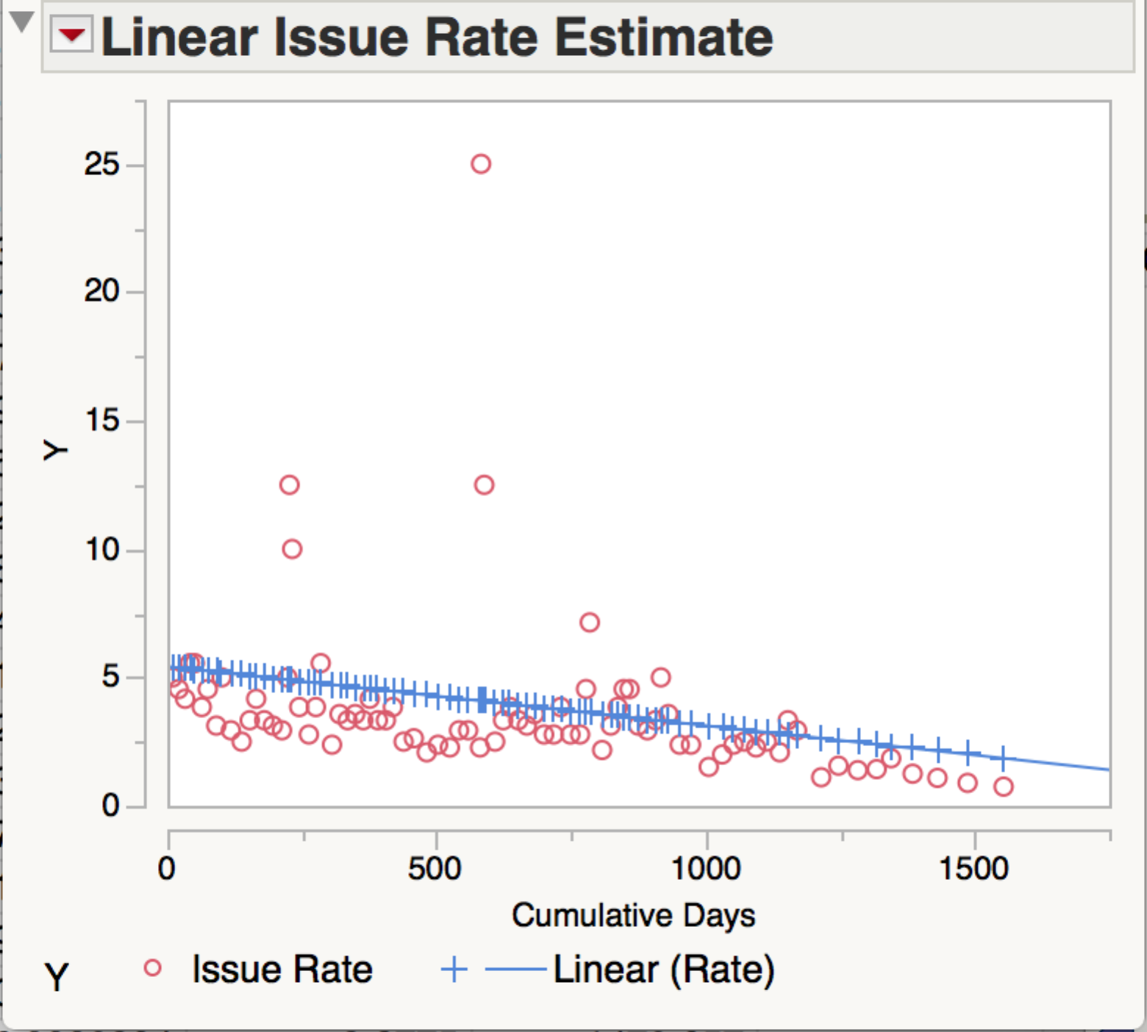

# Relative Error

* The following plot shows the relative error at the latest time for each of the model.

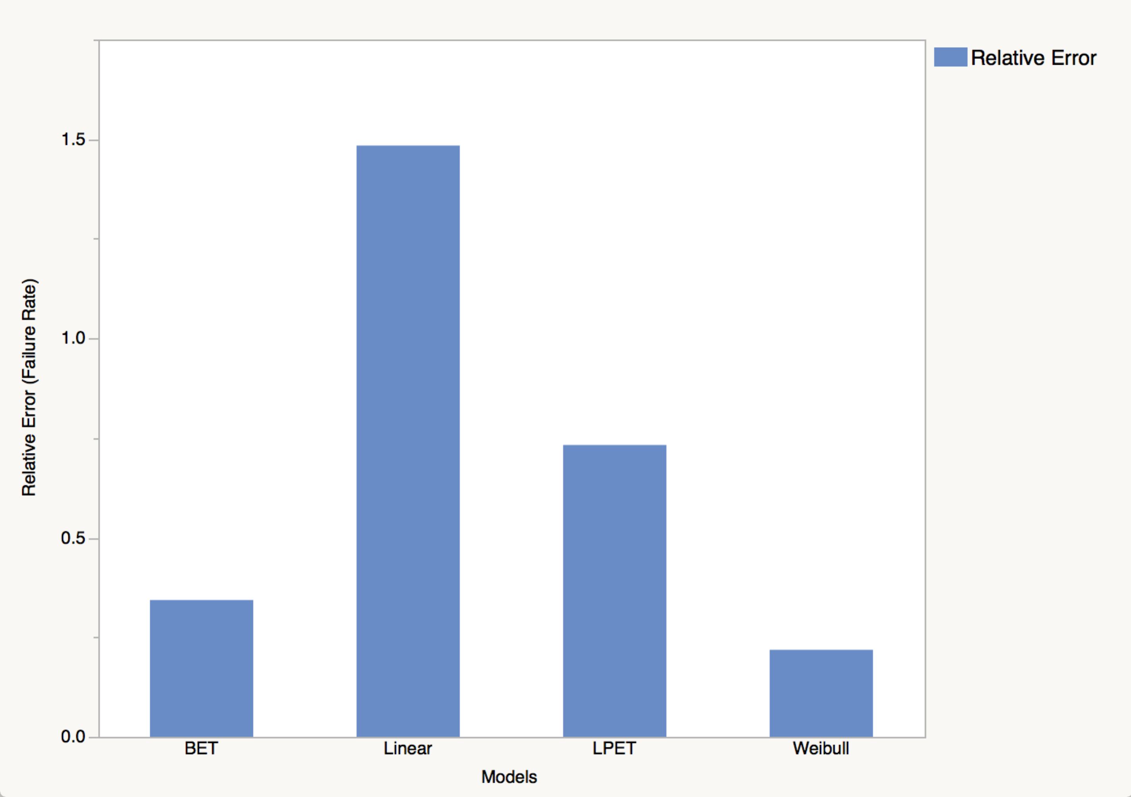

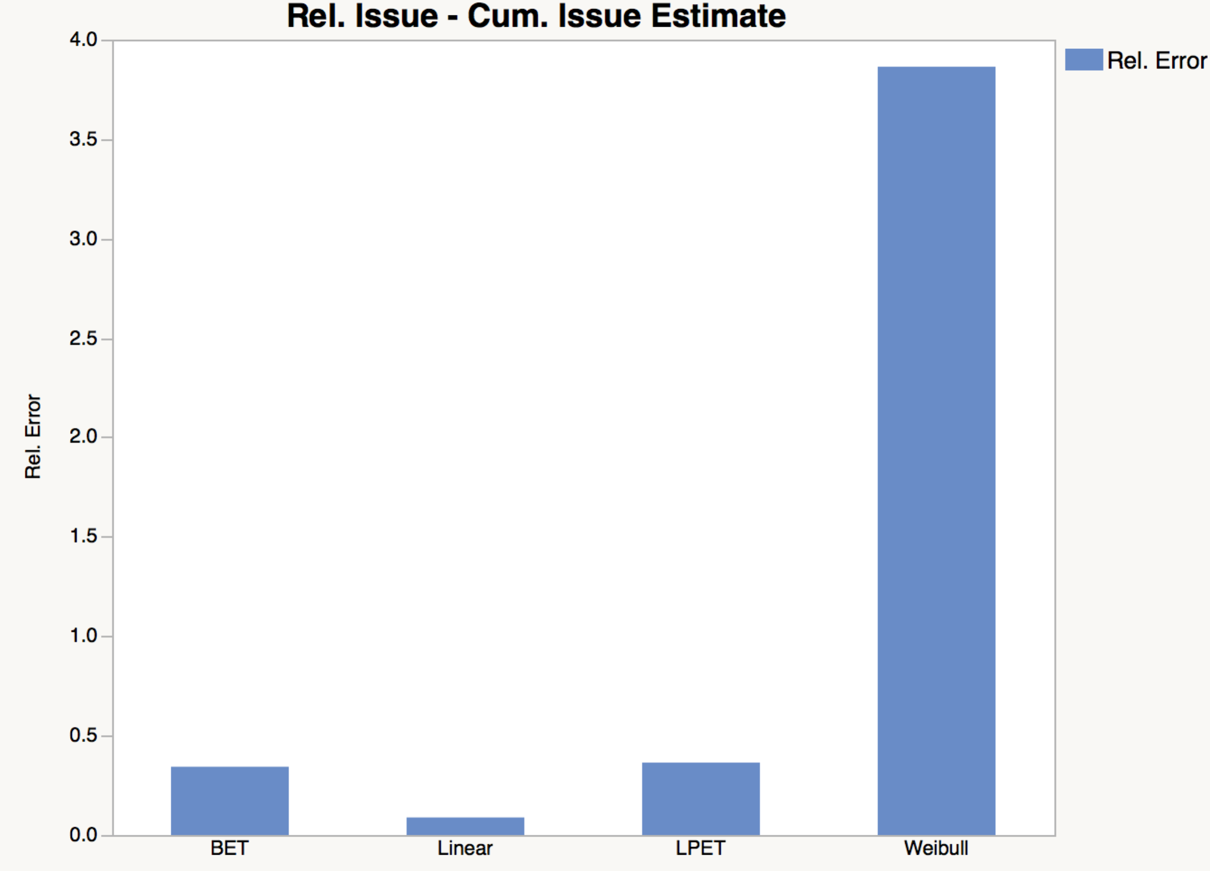

Summary:

1. It can be seen that the least error in the estimation of issue rate is obtained by using the Weibull model.
2. But, in the case of Cum. Issue estimate, the linear estimator produces the minimum error.